Steps to create macro that creates PowerPoint presentation out of Excel charts
- Save PowerPoint template in My Documents folder within your folder in Users folder on C:\ drive.
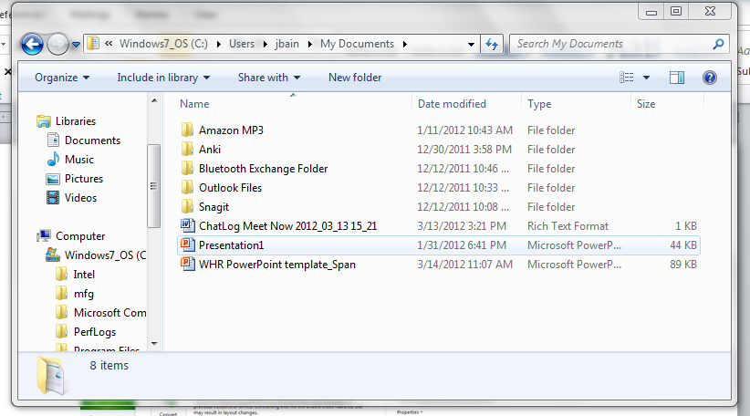
- Close PowerPoint.
- Open Excel document
- Go to File tab, select Options
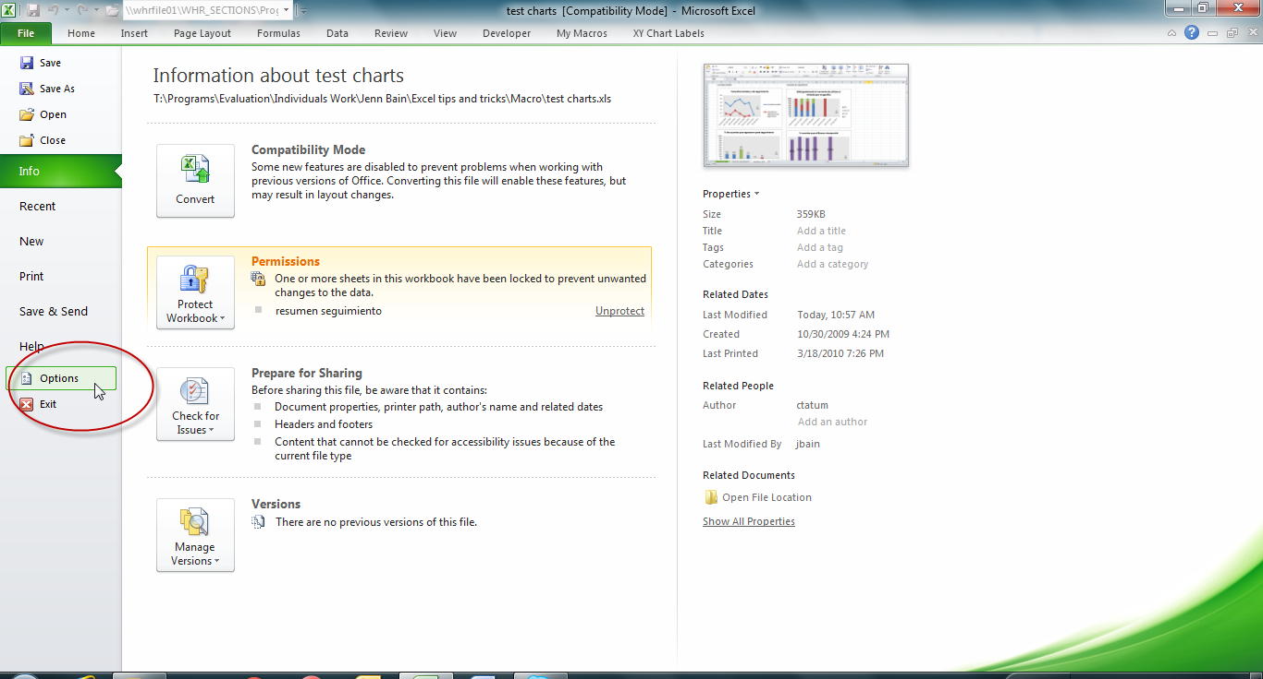
- In Popular, check box “Show Developer tab in Ribbon” or in Customize Ribbon, check Develop on right hand size
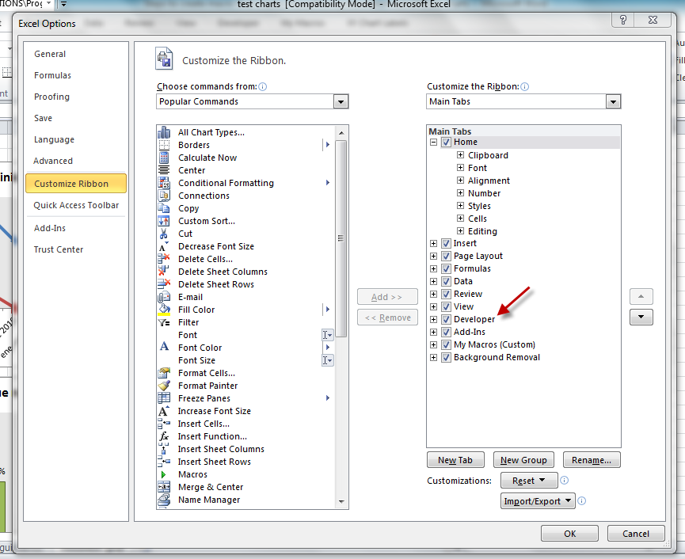
- Click OK.
- Go to Developer tab in ribbon.
- Select Visual Basic for Applications button in Code category.
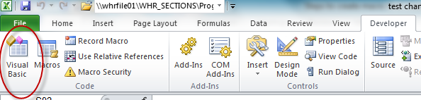
- If you can’t see the “Project – VBA Project” window on the left, go to View in the toolbar and select Project Explorer.
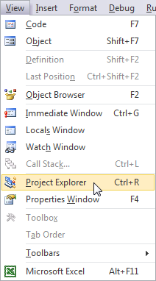
- Expand VBAProject (PERSONAL.XLSB) and the Modules folder within it, then double click on “Module1” so that window opens on right.
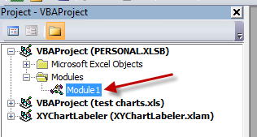
- Copy and paste code from Word document into window.
- In 18th line of code, change file path to the folder where you saved the PowerPoint template (you may just have to change “jbain” to your first initial and last name)
- Go to Tools, then References, and find Microsoft PowerPoint 12.0 Object Library (either at top of list or in alphabetical order toward middle of list) and select check box.
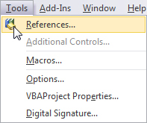
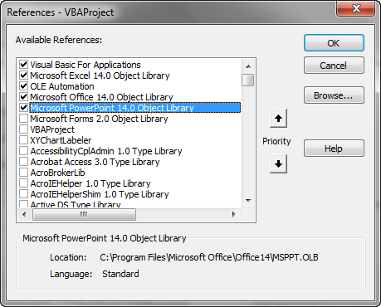
- Click save, close entire VBA window. The code is now added to your Personal Workbook, which makes the macro available to run in any workbook of Excel that you open on your computer.
- To add a button to your Excel ribbon that you can click to run the macro instead of having to remember a keyboard shortcut, go to Office button/File tab, select Options and select Customize Ribbon, then select New Tab.
- Use the Rename button to rename the new tab and the new group within the new tab. You can also select an icon to go with the new group. I chose My Macros and My Macros, respectively, with a bar chart as the icon.
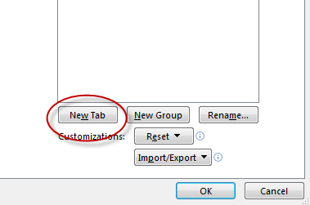
- Now on the list on the left, select Macros from the drop down.
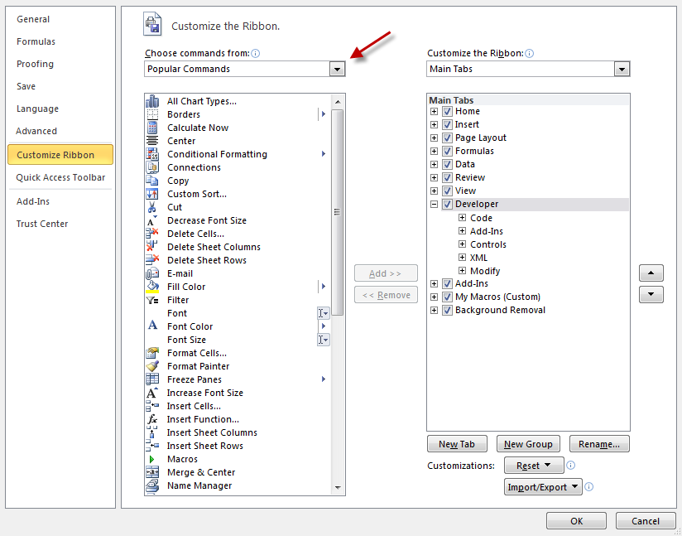
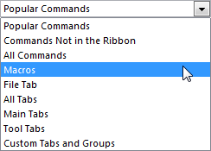
- Select the macro you created, and then click on the Add button to move it over to your tab and new group (make sure you have your new group selected so that it will move the macro into that group).
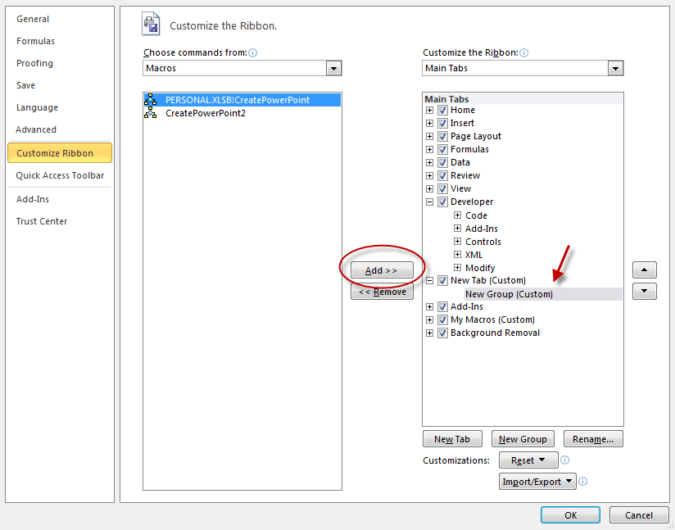
- VOILA!
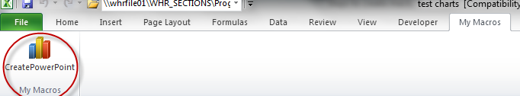

- Go to sheet in Excel workbook with charts.
- Press the button and watch all of your charts magically appear in PowerPoint.
- Once all of your charts are in the PowerPoint, be sure to resave it as another file name so you always have a blank template PowerPoint available for creating new presentations. Also, make sure PowerPoint is closed before you run the macro or it will add the charts to the “active” presentation, or whichever presentation you were working in last. On the other hand, this can be useful if you want to add charts to a presentation you have already created.
Troubleshooting:
- If you get an error that the code cannot run because the personal workbook is not visible, go to the View tab in the ribbon and select Unhide.
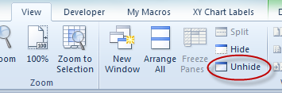
Please contact me with any questions at jennifer.e.bain@gmail.com.
Resources
- General VBA resource
  - Chandoo.org
- Help for Mac users
  - http://answers.microsoft.com/en-us/mac

